1. [15 points] With reference to the term “mean circulatory pressure” …
2. What is the definition of the term?

The mean circulatory pressure is the equilibrium pressure throughout the cardiovascular system when cardiac output is 0 (no flow).

1. If all other physiological variables remain the same, how (increase, decrease, remain the same) is mean circulatory pressure affected by a change in venous compliance? Briefly explain.

The compliance is defined as $ΔP/ΔV$, and it is the slope of the venous function curve. If all other physiological variables remain the same, changing the slope of the curve does not change its intercept with the y-axis which is the mean circulatory pressure thus mean circulatory pressure remains the same and is not affected by a change in venous compliance.

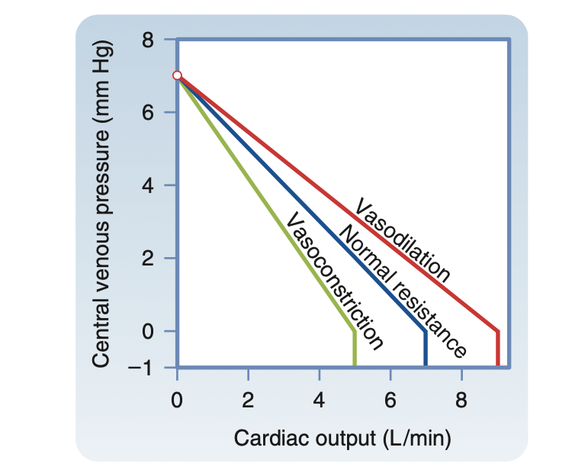

1. If all other physiological variables remain the same, how (increase, decrease, remain the same) is mean circulatory pressure affected by a change in circulating blood volume? Briefly explain.

If there is more blood volume added to the circulatory system without changes in venous compliance or other physiological variables, the mean circulatory pressure increases (transfusion curve in figure below). Decrease of blood volume shifts the vascular function curve downward (hemorrhage curve in figure below), the mean circulatory pressure goes down.

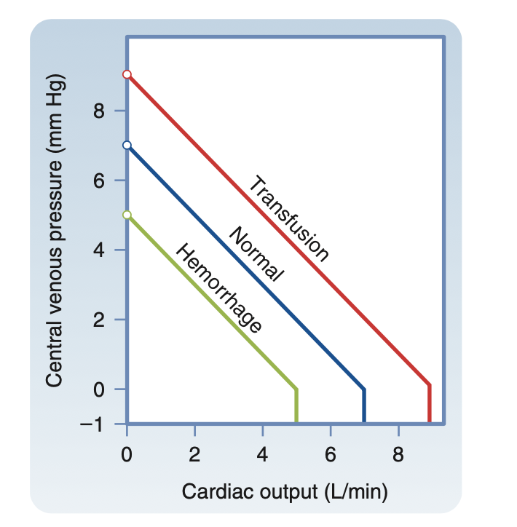

1. [20 points] If drawn on the same set of axes, what is the significance of the point at which the vascular function curve and the cardiac function curve intersect?

The cardiac function curve focuses on how the heart is driven by venous return or venous pressure. Conversely, the vascular function curve expresses the inverse relationship between cardiac output and venous pressure, that is a rise in in cardiac output diminishes Pv. Pv is the dependent variable (or outcome variable) and cardiac output is the independent variable for the vascular function curve. If these two curves are drawn on the same set of axes, the intersection point between these two curves represent the stable values of cardiac output and central venous pressure, it is an equilibrium point, at which the cardiovascular system operates. For a given pair of vascular and cardiac function curves, any perturbation is transient, as it triggers a sequence of changes in cardiac output and venous pressure to restore these variables to their equilibrium values.

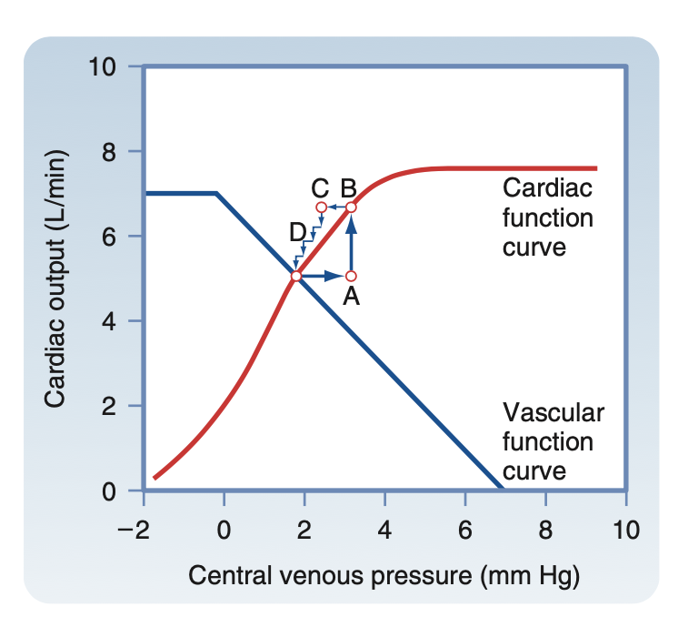

1. [20 points] Sketch a vascular function curve and a cardiac function curve on a common set of axes. Show (sketch) and briefly explain the effect(s) of systemic (i.e., whole body) sympathetic stimulation.

Systemic sympathetic stimulation constricts all the systemic blood vessels.

When systemic sympathetic stimulation increases, total peripheral resistance (TPR) goes up and mean systemic pressure (MAP = CO x TPR, VSL[15] p.411) also goes up. A decrease of the systemic sympathetic activity shifts the venous return curve downward and to the left (yellow curve) from its normal position (black curve) due primarily to a reduction in mean systemic pressure. Maximal stimulation (purple curve) shifts mean systemic pressure higher and shifts the venous return curve upward. (although the slope is reduced due to an elevation of resistance to venous return).

When sympathetic stimulation increases, the vascular resistance goes up, central venous pressure goes down and the cardiac output goes down (read curve labeled depressed). The cardiac function curve shifts downward. When sympathetic stimulation decreases, the opposite happens and the cardiac function curve shifts upward (red curve labeled enhanced).

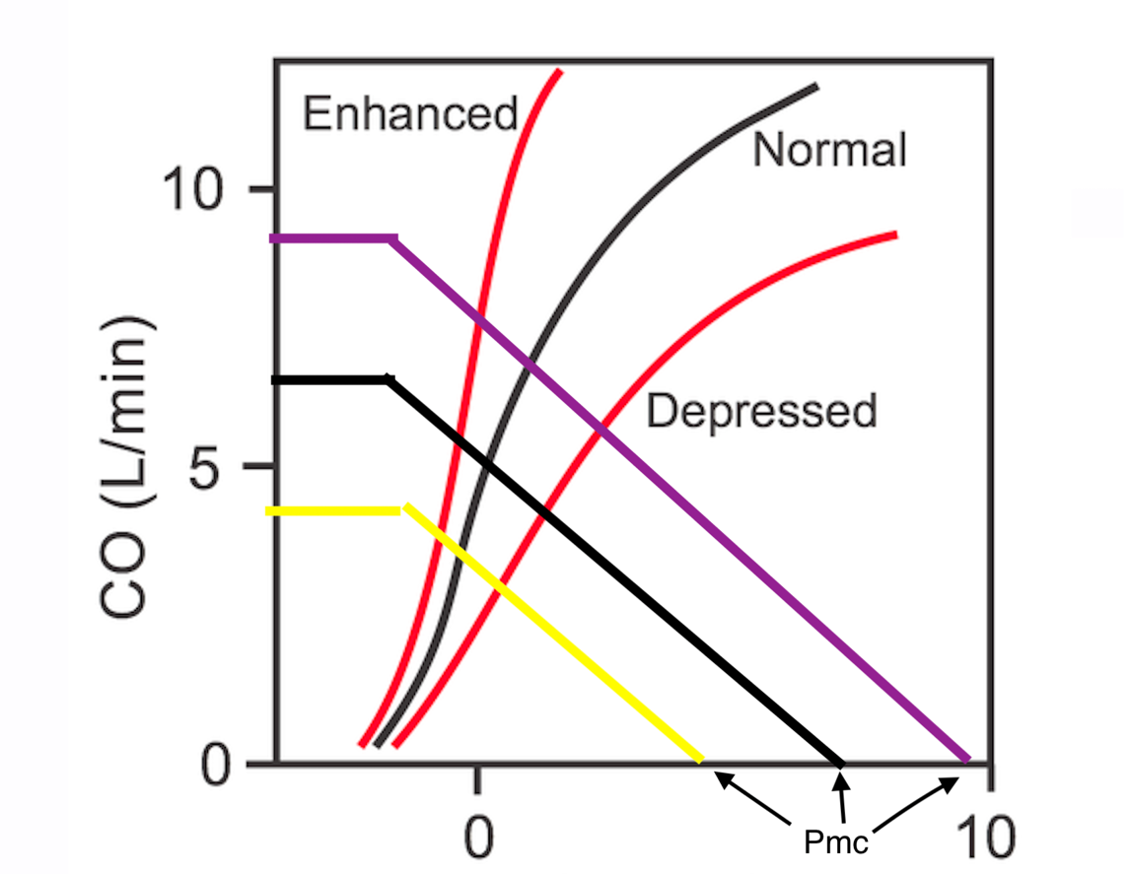

Systemic sympathetic stimulation decreases, total peripheral resistance (TPR) is increased and the vascular function curve is rotated counterclockwise, but it converges on the same Pv axis intercept as the control curve does. The increase in peripheral resistance shifts the cardiac function curve down. And if systemic sympathetic stimulation increases, peripheral resistance decreases, vascular function curve moves clockwise and the cardiac output curve shifts upward.